**Re:Time VR Technisch Ontwerp**

Re:Time is een VR FPS met tijd gebaseerde mechanics en een focus op arcade Re:Time VR Technical Design

Re:Time is a VR FPS with time based mechanics and a focus on arcade gameplay (Different Levels with a focus on Replayability) and Tenet style astetics.

**Overview:**

- Supported Headsets: Oculus Quest 1&2 (PC), Valve Index, HTC Vive and WMR (OpenXR Standard)

- Game Engine: Unity 2020.11f1

- Coding Language: C#

- Genre: Action/Stealth/Sci-Fi

In this game, combat revolves around one gun with various unlockable skills that often have to do with time control. There is a Progression system that allows you to constantly upgrade your gun with different abilities and buffs.

**Setting:**

You are an astroneer that finds a gun with Time controlling abilites and needs to fight people trying to steal it. The game takes place in a big spaceship.

**States:**

Player States:

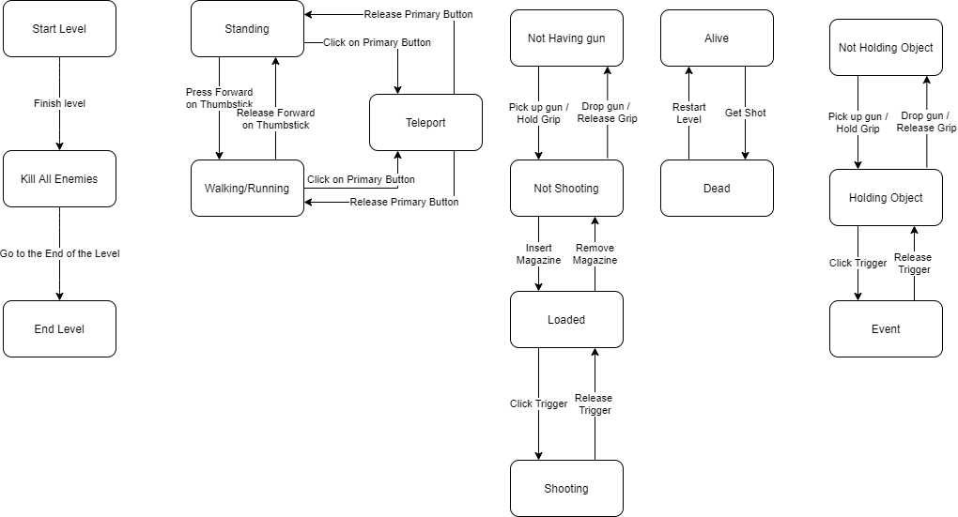

Enemy States:

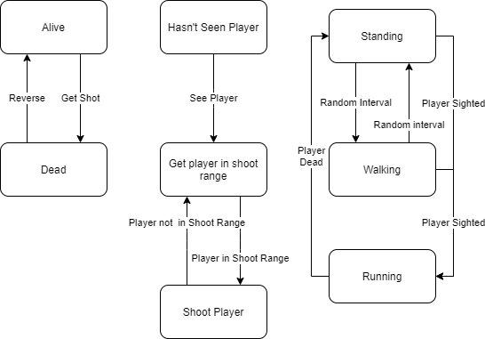

**Game Progression:**

**1.Game Levels:**

* + The levels are the different levels of space
    - Level 3 of the Space is level 1 of the game
    - Level 2 of the Space is level 2 of the game
    - Level 1 of the Space is level 3 of the game
    - Different weapon magazines are available on different levels of the game i.e. the higher the level the better the weapons
  + To complete a level :
    - The player must Kill All enemies

**2.Difficulty Levels:**

* + Easy, medium and hard
  + User can choose difficulty level to play at the start of a level
  + The harder the difficulty level the more/and varied enemies

**Mechanics**

**Primairy mechanics:**

* The player can walk, Teleport, Slow down Time, and shoot.
* Guns and knives can be used to interact with the enviorment.
* Guns and melee weapons have time controlling mechanics (Time Slowing Down, Time Stopping, Time looping)
* The Player can interact with the enviorment (Doors, chairs and objects)

**Secondary mechanics:**

* Objects in the enviorment can be used and most of them are a physical instance of an object.
* Vehicles can be used in the enviorment.

**Mechanics:**

**1. Rules:**

* + Player cannot jump
  + If the characters health reaches zero then that character dies and that level needs to be repeated
  + Characters cannot get through levels without killing all enemies
  + The player cannot progress to the next level without completing the previous
  + level
  + Characters cannot run through walls or doors that are closed
  + The players view is purely from a first persoon perspective
  + Player starts with no weapons and collects weapons on the way
  + If the players character is killed by a enemy then the level must be started again
  + There are only three options with the weapons collected:
    - Hit with the weapon
    - Shoot with the weapon
    - Throw the weapon

**2. In-game Help and Info:**

* + When the game starts up the player is prompted to do the following actions (to help understand how to play the game):
    - Move around
    - Look around
    - Interact with objects
    - Teleport
    - Shoot
    - Turn
  + Help can be accessed via the main menu. This will include the following topics:
    - Levels previously completed
    - Main Menu
    - Settings
    - Quit

**3. Game Logic:**

* + Gun Attachments are interchangeable but they don’t stack
  + Characters can’t jump
  + Characters cannot run faster than a typical human in real life
  + Enemy characters are not agile
  + Enemy can use multiple different weapons

**4. Objective(s):**

- Navigate through the Level

- Defend yourself against enemies

- Gather Gun attachments to have more ways to fight enemies

- Get health to keep alive

**Dynamics**

* Enemies scale up with the player so the sense of difficulty is maintained throught the game.
* Player Gets Multiple Forms of time control that are attached to the gun.
* Multiple bigger different maps with different people to kill and interact with.
* Different types of enemies that attack the player
* Points are awarded for killing enemies and completing objectives

**Aesthetics**

For astetics I want to focus on sensation and challenge so good music, style and flow. There will be no story so I can work on combat, mechanics and things that make the gameplay better for challange.

A VR headset helps a lot when I want to focus on sensation because controllers have rumble and it feels like you are really there.

I also take inspiration from the movie Tenet and the game Arcadian Rifter.

**Demo Goals:**

**Demo 1**

Things I want to finish in demo 1:

- Working locomotion (Teleportation and smooth movement) [Check].

- A working XR Rig [Check]

- Menu, Pause screen, Tutorial and Testing Area [Check]

- A working gun (Shooting and reloading) [Check]

- Basic Time Mechanics Implementation

**Demo 2**

Things I want to have finished in demo 2:

- Improved Graphics & GUI

- Optimizing performance

- Working Enemies

- Level System

- Multiple Time Mechanics attached to the gun

- Working Oculus Quest Build [Check]